Key Instant Recall Facts (KIRFS) (set 1)
These are maths facts that children should learn in year 1 to help with quick recall and fluency. We will revisit these each term.
TO UNDERSTAND - Even numbers end in 0,2,4,6,8

Like 2 or 12 or 22 or 32 and so on
TO UNDERSTAND - Odd number end in 1,3,5,7 and 9.

Like 3 or 13 or 23 or 33 and so on
TO KNOW - Doubles of all numbers to 10.

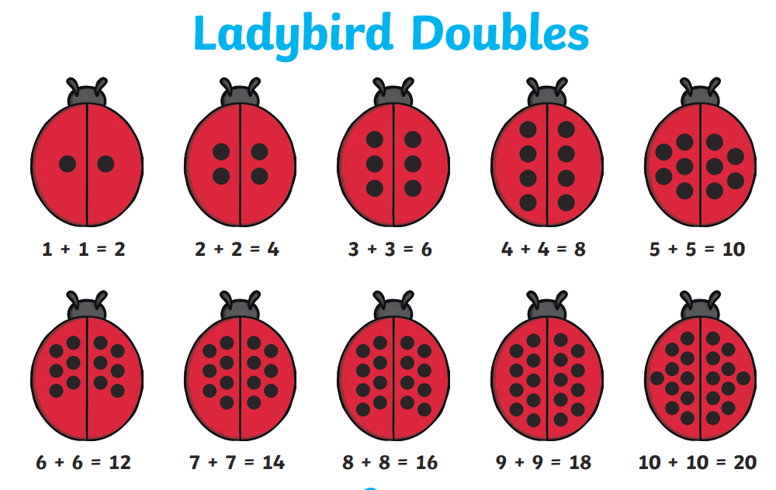

FACT - Adding (+) makes a number larger.



